

Dr. Sara, Taylor inc.

2020-02-04

Dr. Taylor

61542 Quinn Falls, Port Susanside, WI 07234

Phone: 4327609811

Fax: 2876176623

**Re:** Catherine, Smith

**PHN:** 9936513901

**Birthdate:** 01-Jul-2000

**Address:** 69855 Jennifer Gateway Apt. 319, Crystalborough, NE 30749

**Patient number:** 7917490956

To Whom It May Concern:

This is a medical letter to state the above patient is pregnant with expected delivery date of 13-Jul-2025. Hoping this information is satisfactory for your requirements.

Thank you.

Sincerely,

Dr. Sara, Taylor

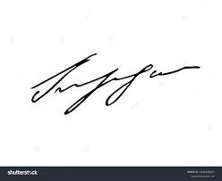

FRCS© NCMP

Clinical Assistant Professor, UBC

Department of Obstetrics and Gynecology SMH